Session 2 – JENKINS

Goi to manage Jenkins and then manage plugins

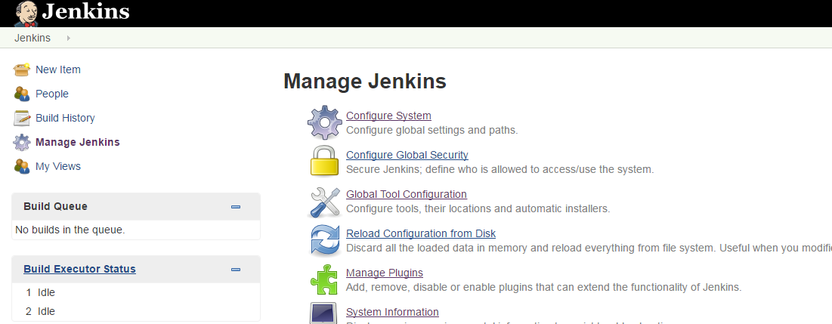

To install

Search “jenkins bitbucket plugin” on google and enter to Wiki

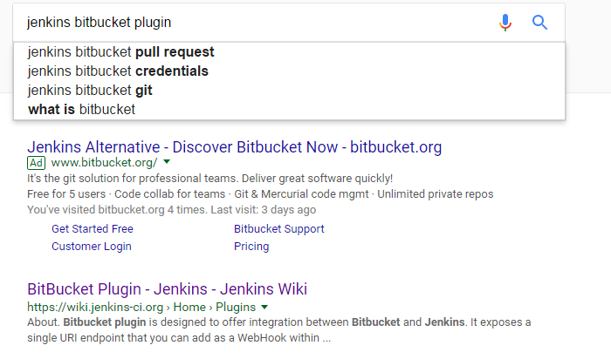

Download .hpi file and upload :

Choose advanced

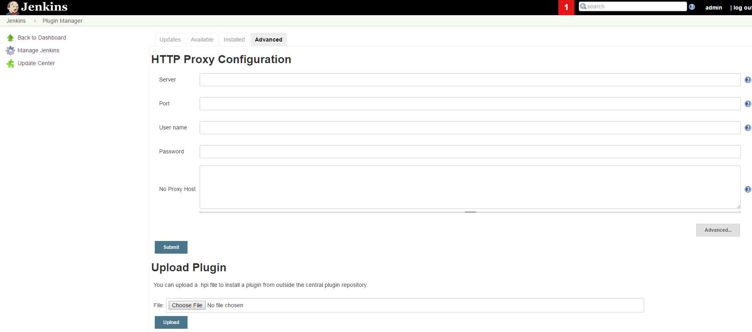

Then choose plugin, select hpi file and upload

. install all the following

Check on path:

C:\Users\B03831A\Desktop\How To\Jenkins\Plugins

RESTART JENKINS

Control Panel\All Control Panel Items\Administrative Tools

Execute

Services with admin user

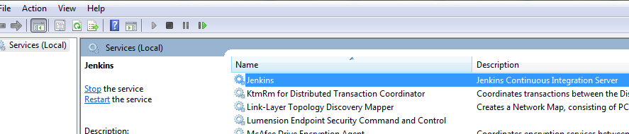

Restart jkjenkins server

After download and install those you need to configure those:

Manage Jenkins ;

Configure Systems;

Go to

|  |  |  |  |
| --- | --- | --- | --- |
| **Global properties** | | | |
|  |  |  |  |

Mark Environment variables

Then Add the following variables

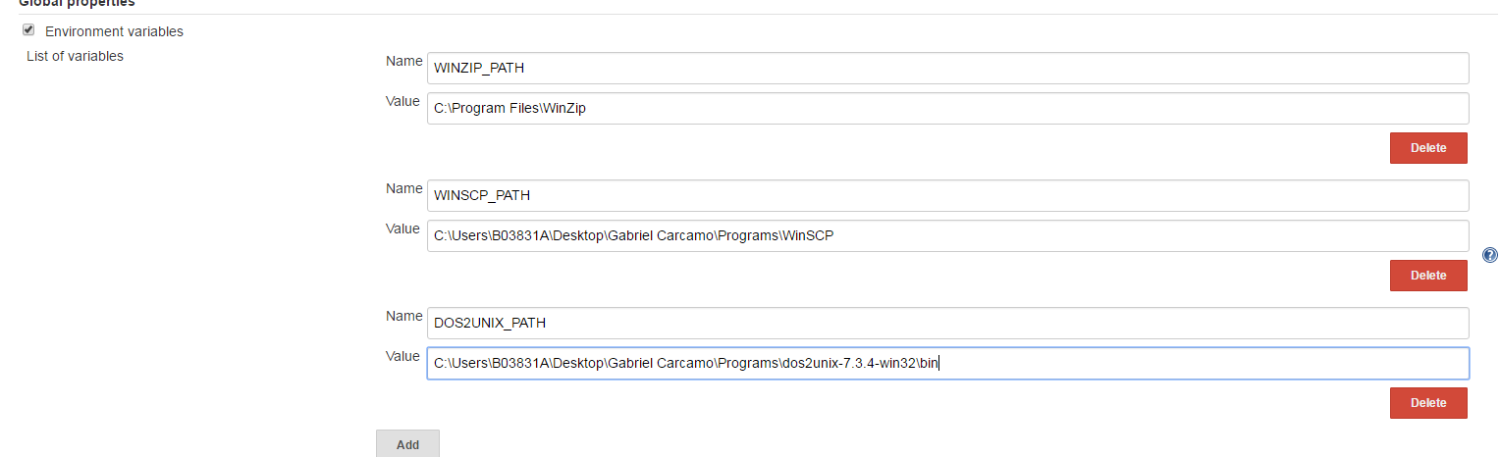





Winzip should be in your computer

Add your email on this section

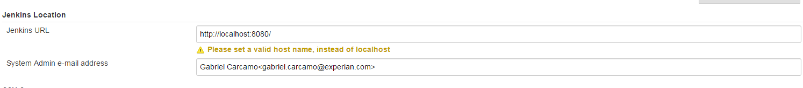

Set email variables

